Your Name: Megan Coley
Name of Book/Author: SantaKid by James Patterson
Name of Activity: Sleigh Helpers
Curriculum Area: Science
Skills (-ing): Differentiating between flying and non-flying animals.
Materials Needed: Picture cards of animals that fly and animals that do not fly.

Opener: How many of you know all the names of the reindeer that pull Santa’s sleigh? What is the difference between an animal that can fly and an animal that can’t fly? How do you know those animals can fly? (Create discussion) Today we are going to help Santa fly his sleigh by choosing which animals can already fly from the pile of pictures!

Activity: Sit the children on the floor of the classroom. Tell the students they need to help Santa this year. Explain to the students that Santa, in his old age, has lost his ability to make reindeer fly. Tell students that he must now select new helpers by picking animals that can already fly to pull his sleigh. Give students the animal pictures you prepared and ask them to sort them into two piles, one pile consisting of animals that cannot fly and, as such, could not help Santa and another consisting of animals that can fly and therefore would make great Christmas Eve helpers.
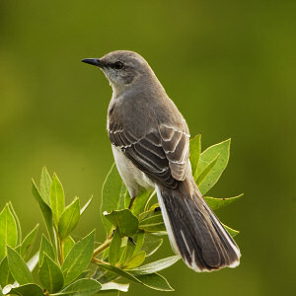
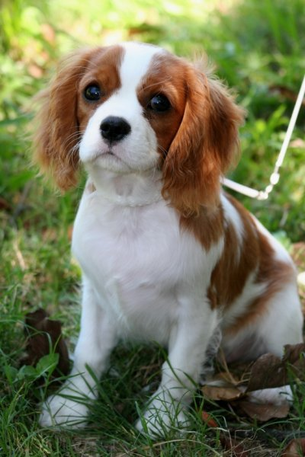

VS.

Closure: Which animals from the pile (that you remember) can fly? How could you tell that those animals could fly? What are the differences between those animals that could fly and those that could not? How did you decide that the animal could fly or not? Do all animals with wings fly?

Source: http://www.ehow.com/list_7262007_christmas-science-games.html

